Attach a photo of your Business Cycle diagram below

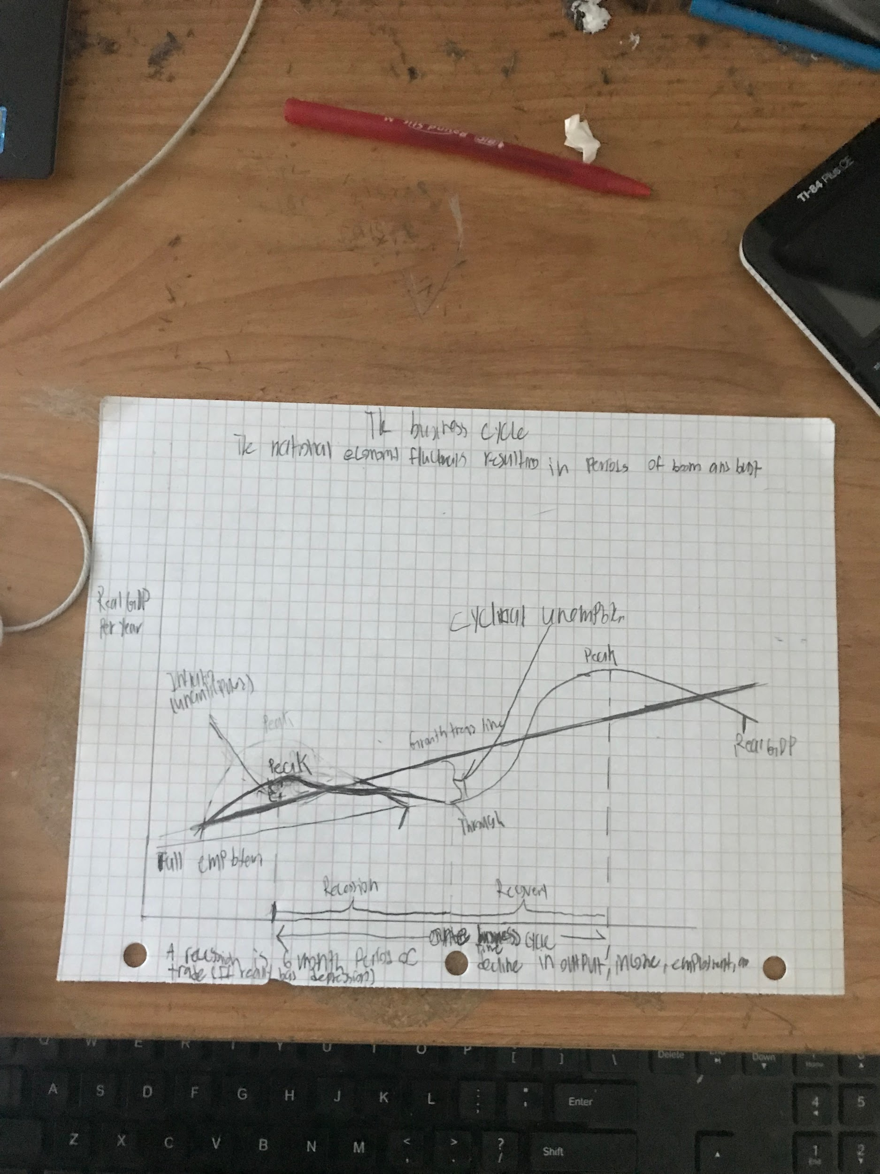

| What comes to your mind when you hear the terms “Recession” or “Depression” | The Stock Market Crash of 1929, World War 2 and the Great Depression and FDRs first 100 days come into my mind when i think about recession and depression |
| --- | --- |

| What does the wavy curve represent? | The wavy curve represents the growth and decline of the GDP. The national economy fluctuates in periods of booms and bust. |
| --- | --- |

| What is a recession? | A recession is a 6 month period of decline in output, income, employment, and trade. A 6 month period of decline in GDP |
| --- | --- |

| What is an economic depression? | A prolonged and severe recession  Severe declines in  Production/output  Income  Employment |
| --- | --- |

What are the 3 statistics about the Great Depression that we talked about?

| At one point, stocks lost 80% of their value |
| --- |
| At one point, ⅓ of the banks were bankrupt |
| At one point, the unemployment rate reached 25% |

| What is an expansion/recovery? | A period where there is an increase in GDP  Increase in  Production/Output  Income  Employment |
| --- | --- |

| What often happens to GDPr in times of war? | It increased by a whole lot during the war. |
| --- | --- |
| Why? | Real GDP increase because the government spend so much money on government expenditures. War leads to expansion when the government spends for business investments |

| 6 Characteristics of a Recession |  |
| --- | --- |
| More unemployement | More social problems(alcholism,domesticviolence, divorce, and suicides) |
| Decrease in Real GDP |  |
| Reduced job growth |  |
| Lower interest rates |  |
| Decreasing prices |  |

| 6 Characteristics of an Expansion |  |
| --- | --- |
| Less unemployement | Fewer social problems(alcholoism, domestic violence, divorce, and suicdies) |
| Increase in real GDP |  |
| Rapid Job growth |  |
| Increasing interest rates |  |
| Increasing prices |  |

| What are the 3 Macro Goals for a government? | Macroeconomics measures these fluctuations and guides policies to keep the economy stable. The governmenthas the responsibility to |
| --- | --- |
|  | 1)Promote long-term gorwth |
|  | 2)Prevent cyclical unemployment(Resulting from a recession) |
|  | 3)Minimize Inflation(Resulting from a recovery/expansion) |

| Type out a multiple sentence paragraph about why Macroeconomics is relevant and important to your life and future | Macroeconomics is important about our life and our future, because it helps us understand when we could loose our job and lose money. We also understand that with macroeconomics it helps how to chose jobs wisely and spend more money. When there are less growth we can unsterand to make better choices |
| --- | --- |